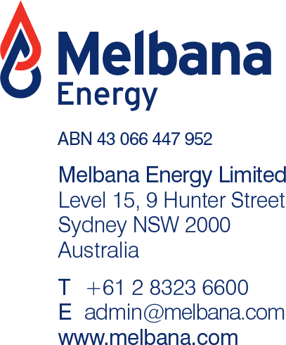

Alameda-1 Drilling Update
Highlights

- Another zone of interest has been encountered leading up to 1842 metres, with good oil shows and elevated gas readings

- Preparations are underway for the logging of this new zone as well as the zone with good oil shows that occurred over a 670 metre interval commencing just below the first casing point at 455 metres, at as previously reported

- The primary targets of the Alameda-1 well still lie ahead

SYDNEY, AUSTRALIA (12 OCTOBER 2021)

Melbana Energy Limited (ASX: MAY) (Melbana) is pleased to report the following update on the progress of the Alameda-1 exploration well being drilling in Block 9 PSC, onshore Cuba.

Over the past week, drilling of the Alameda-1 well continued to a depth of 1,842 metres with the well encountering increasingly strong influx of gas with some oil (the latter as evidenced by the smoke and colour of the flare, shown in Figure 1). Flaring procedures were implemented to manage the influx while mud weight was increased to suppress it. As this was done without testing equipment it is not yet possible to confirm the proportions of oil and gas nor the flow rate, but these results suggest there are now at least two intervals in the secondary objective that need closer examination.

Drilling progress during the week was hampered by some minor mechanical problems, which have now been repaired, and the need to manage the higher-pressure zone and gas/oil influx, noted above. It has been decided to acquire a suite of wireline logs then run a 11-3/4” liner to seal off the drilled section at the current depth. This will allow drilling to then progress in a controlled manner to the primary objectives with a higher mud weight, thus avoiding possible damage to the shallower strata.

Operations at the wellsite are now preparing the hole for electric logging of both the higher zone (gross thickness of 670 metres down to 1,130 metres), which had good oil shows over a significant interval, and this new higher-pressure interval at approximately 1,842 metres. Analysis of the log data will help evaluate the significance of these encouraging hydrocarbon indications encountered to date.

Melbana Energy’s Executive Chairman, Andrew Purcell, commented: “Exploration drilling often provides unexpected results and thus requires flexible responses. Whilst drilling has not progressed as far as we had projected this past week, this was due to encountering a higher-pressure zone earlier than we expected. The gas and oil influx into the well bore (following the earlier significant thickness of reported good to excellent oil shows) provides even more encouragement regarding this shallow part of the well. We await the results of the electric logging - which have been brought forward from the original plan - with great interest. It is important to remember that the pre-drill synopsis for this well is that the two main (primary) targets are yet to be reached”.
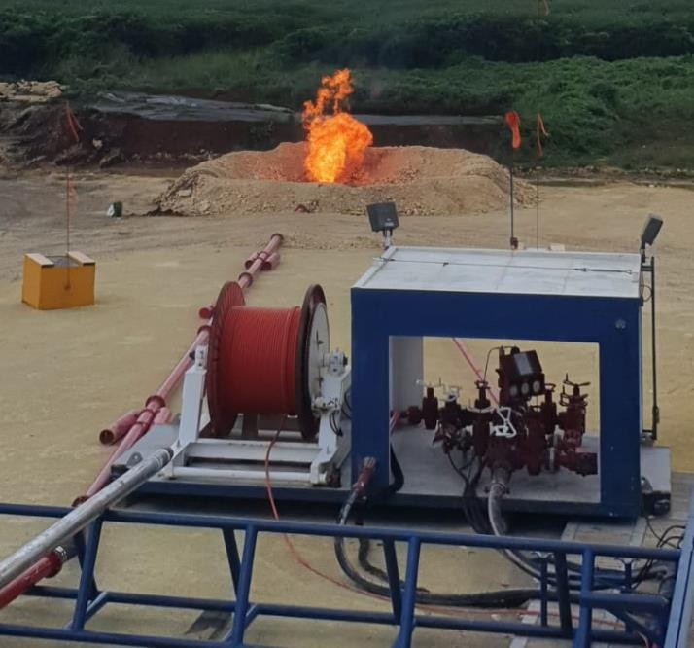
Figure 1 - Flaring of hydrocarbons encountered in the high pressure zone commencing at 1,842 metres

Civil Works

The first tier of the well pad for Zapato-1 has now been completed. Work has now commenced on the build up of the second tier. Progress remains on schedule.
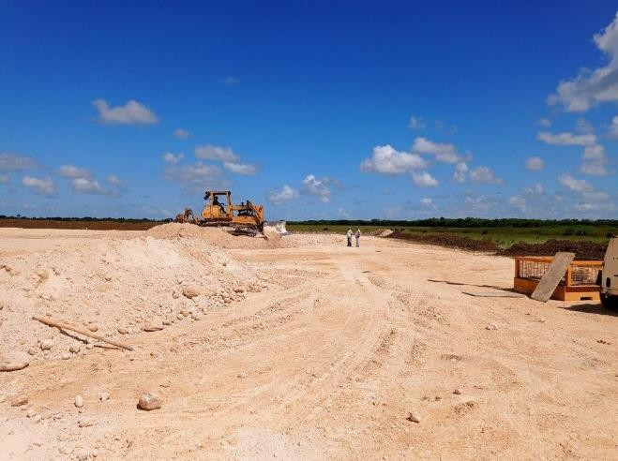
Figure 2 - Zapato-1 well pad now building up the second tier

For and on Behalf of the Board of Directors: | For further information please contact
Mr Andrew Purcell | Mr Theo Renard
Executive Chairman | Company Secretary
 | +61 2 83 23 66 00
Ends -

