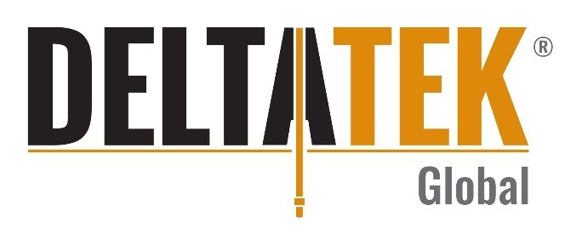
DeltaTek partners with GS Oilfield Solutions in Norway
News release – 12-03-2020
Aberdeen-based well construction specialist, DeltaTek Global, has partnered with GS Oilfield Solutions to support its ongoing expansion in the Norwegian North Sea.
GS Oilfield Solutions, based in Stavanger, Norway, offers resourcing services of all types of equipment required by the global oil and gas specialising in premium products within the drilling and well intervention sectors.
DeltaTek, which fully commercialised 18 months ago, and has continued to experience significant expansion both in the UK and overseas, has agreed to formalise their partnership with GS Oilfield Solutions, supporting their strategic expansion in Norway. GS Oilfield Solutions will provide DeltaTek’s Cure service line to the region, including SeaCure, QuickCure, CoreCure and ControlCure.
Commenting on the partnership, DeltaTek’s CEO Tristam Horn said: “We are delighted to be partnering with such a well established and respected business in Norway. Last year, we made a commitment to the region and this relationship continues to solidify our dedication to saving rig time for operators in the Norwegian North Sea.”
Stian Krag, CEO of GS Oilfield Solutions, commented: “We are delighted to have entered into this partnership with DeltaTek, as their innovative technologies are game changing for oil and gas industry, and we believe that these technologies and processes will become the standard way of cementing in the future. In the coming years we believe that this partnership will play a major part in our offering to the Scandinavian oil and gas industry.”

ENDS
Photo cap: Tristam Horn, DeltaTek CEO.
Notes to editors
Issued on behalf of DeltaTek by think. For more information, contact Jamee Kirkpatrick on 01224 623960 or email jamee@thinkpr.co.uk // Rachel Creegan on 01224 623960 or email rachel@thinkpr.co.uk
Listen to what the operators have to say about SeaCure here: https://youtu.be/lxwpgPP2nUw
www.deltatekglobal.com
About GS Oilfield Solutions AS
GS Oilfield Solutions AS is a Stavanger based company founded in 2016 specialising in offering the Scandinavian oil and gas industry best possible solutions across several core areas, including:
- Designing solutions for well intervention
- Specialist fishing solutions
- Designing decommissioning solutions
- Management consulting services
- Representation of international companies to Scandinavian market
- Sales, rental and sourcing of equipment for O&G industry

